 | GARNTEG PRIMARY SCHOOL  Hillcrest Garndiffaith Pontypool Torfaen NP4 7SJ  01495 742934  head.garntegprimary@torfaen.gov.uk  www.garntegprimary.co.uk
 | 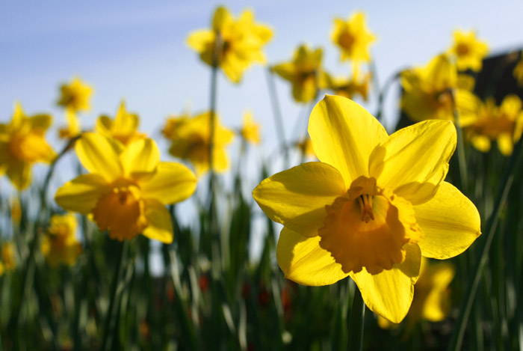

Lythys – Newsletter – 5th March 2021
This half term our value is: Thoughtfulness

Important Dates for your diary
Easter Holidays – Friday 26th March – Monday 12th April
Spring Half-term – Monday 31st May – Friday 4th June
Inset Days – Friday 28th May
Monday 19th and Tuesday 20th July

Dear Parent/Carer,
Annwyl Rhieni

Well done for another great week of excellent online learning we are delighted to have all of our foundation Phase Pupils back in school and lovely to see our parents.

We have had a busy week in Garnteg with St David’s Day and the Eisteddfod on Monday, Llongyfarchiadau to all our Eisteddfod Winners and to everyone who took part. It was lovely to see you all in your costumes.

Also thank you to all our pupils who dressed up as their favourite book characters for World Book Day yesterday, you all looked amazing.

Return to school for Key Stage 2 Juniors from March 16th
We are really excited to welcome back our Key stage 2 pupils from March 16TH All KS2 pupils will be returning the Monday 15th will be used as cleaning day from the 5 remaining hub classes in yrs3/4/5/6. It is anticipated all pupils will return on this date Tuesday March 16th . Like the Foundation phase return all families will be given a time slot where they drop their pupils off according to their alphabetical surname. It will be extremely important to keep to these times and not arrive earlier than your allotted times as this will cause overcrowding at the gates.
The return to school letter for Key Stage 2 will be available with times for your return on Monday 8th March and put on all social media etc. School Uniform is to be worn including comfortable trousers/joggers and trainers for outdoor activities. A Packed lunch will be needed.

Existing Foundation Phase
Parents are also required to bring pupils (one adult only) and to wear a mask when dropping off and picking up from schools to reduce community transmission. To avoid chaos at the school gates please can we ask that parents keep to the appointed times for their children. Rec-Y2 Pupils with surnames A-L 8:50- 2:55 and surnames M-Z 9:05-3:10. Thank you for your support in keeping our community safe.

Maintain a clear social distance at the school gates will also reduce risk and set a good example to pupils. Nursery pupils and siblings of children please use bottom gates.
Along with regular hand washing/sanitising and social distancing, this will reduce the risk of spreading COVID-19 at school as far as possible.
Rules have been made stronger to keep you and your families as safe as possible. They are based on new advice from Welsh Government’s Technical Advisory Group, as we learn more about the way COVID-19 is transmitted.
Thank you for your help in doing all we can – together - to keep ourselves and others safe.

More information can be found on Torfaen website link below:
Coronavirus Updates - Education and Learning | Torfaen County Borough Council

Vacancy for Parent Governor

Would you like to be more involved in your child’s education? If so why not consider becoming a school governor. All schools have places for Parent Governors and we currently have a vacancies for two (2) of these positions at Garnteg Primary, if you are interested please contact the school office for a nomination form. Governors make decisions about many aspects of the school including the curriculum, staffing and the school’s finances. This role is essential to the education of children in the Borough of Torfaen so please consider standing. In case you feel a little apprehensive about the responsibilities of the role, EAS (Education Achievement Service for SE Wales) Governor Support offer training to assist you.

WG Parental Behaviour Campaign

A potential change in parental behaviours has been a cause for concern with 3 – 7 years olds returning for face to face lessons at the start of this week. We are keen to ensure that there are clear and consistent messages to parents highlighting behaviours that need to be followed to keep schools and childcare open for their children.

Lessons learnt from focus groups with parents have informed development of a series of messages and assets to help communicate with parents/carers.

We have set up a new Keep Wales Safe Education asset back page (which include assets from PHW)
https://wales.assetbank-server.com/assetbank-wales/images/assetbox/ac9d6e27-281f-4600-8ffc-474766ddc005/assetbox.html

wi-fi; to enable your child to complete their online learning.
Pupil of the week in classes

Foundation Phase |  | Key Stage 2
Class | Pupil of the Week | Class | Pupil of the Week
Nursery - Miss Hudspeth | Bobi-Ray & Miyah | Class 7 - Mrs Lewis | Isabella
Class 1 - Mrs Ngwenya | Grace | Class 8 - Miss Paske | Seren
Class 2 - Mr Key | Mali | Class 9 - Mrs Rogers | Ella
Class 3 - Miss Bones | Henry | Class 10 - Mrs Messore | Harvey
Class 4 - Miss Brooks | Euan | Class 11 - Miss Grimas | Lana
Class 5 - Mrs Lee | Taylan | Class 12 - Miss Williams | Sofia
Class 6 - Miss Carroll | Jensen | Class 13 - Mrs Parker-Evans | Ruby B
 |  | Class 14 - Mr Phillips | Cai

Nursery - Da iawn Meithrin for your amazing Eisteddfod entries! The Nursery staff were very impressed and we enjoyed celebrating all your hard work on St David’s Day. We look forward to welcoming our rising 3 children next week. Please can only one adult drop off and pick up the children at the bottom gate and wear a mask when doing so. Diolch, have a great weekend!

Dosbarth 1 & 2 – Bendigedig Dosbarth Un and Dau, what an exciting week we have had! A huge thank you for your wonderful Eisteddfod work, we loved celebrating the day with you this week and will be displaying your beautiful work in our classrooms. We also loved seeing your fantastic World Book Day costumes and activities too! Please can we remind parents/carers that the children can bring a healthy snack to eat at snack time such as a piece of fruit or yoghurt, however the children will need to bring their own spoons for these. Diolch, have a lovely weekend!

Dosbarth 3 & 4 – Da iawn Dosbarth 3 & 4 for another amazing week! We had a very successful Eisteddfod, with lots of awards given out, and your work has been displayed in our classes. We are so proud of you all. We have also enjoyed celebrating World Book Day together and seeing all of your wonderful costumes! We look forward to seeing you all on Monday for another busy week. Have a lovely weekend and keep climbing to sparkle.

Dosbarth 5 & 6 - WOW Blwyddyn Un a Dau, what a fantastic week we have had! We have been amazed by all the entries for the Eisteddfod and congratulations to all our winners. You all looked amazing on World Book Day too, it was lovely to celebrate these in school with you! You have all been working so hard in school this week and we are very proud of you all. We can’t wait to see you all next week for more adventures in our topic ‘Time Travellers.’ Please continue to keep an eye on Twitter and ClassDojo for information and any updates. Many thanks for your continued support. Have a lovely weekend!

Dosbarth 7 & 8 –
Da iawn Blwydden 3 for an amazing week! We have been overwhelmed with all the Eisteddfod competition entries. We would like to say a big DIOLCH to all those children who entered our St David’s Day competitions and also a big BENDIGEDIG to all the winners. We have had wonderful celebrations this week for St David’s Day and World Book Day. You have all been working so hard. Diolch for all your hard work and we can’t wait to see you all nect week for another week of blended learning. Have a wonderful weekend. 😊

Dosbarth 9 & 10 –what a fantastic week of blended learning and live lessons this week. It was so lovely to award the certificates for the entries in the Eisteddfod ceremonies that we had in our classes-you are all superstars. It was a pleasure to hear them cheer each other when somebody won. We would like you to continue to encourage your child to continue using the My Maths and Bug Club websites on a weekly basis. Please let us know if you need the log in details via a dojo message. We hope you have a lovely weekend and we look forward to seeing the children next week on TEAMS.

Dosbarth 11 & 12 –
What a fantastic week in Dosbarth 11 & 12 again! Da iawn to everyone for taking part in Eisteddfod activities and world book day activities, we have thoroughly enjoyed this week and seeing your amazing creations! Once again you have worked super hard uploading all of your work and joining in in live lessons. Keep climbing to sparkle Dosbarth 11 & 12, have a lovely weekend and stay safe.

Dosbarth 13 & 14 -
What a busy week it has been with both St David’s Day and World Book Day being celebrated this week. We loved seeing all your entries for our Lockdown Eisteddfod and well done to all our winners in each of the competitions. For pupils in Y6, a big part of the Eisteddfod is the Bard Writing competition. Well done to Ruby and Kayleigh for being joint winners of the competition this year and being named School Bard for 2021. Thank you for all your efforts. Have a relaxing weekend and we will see you all online again on Monday.

Kind regards,
Mrs S E Roche & all the staff at Garnteg Primary School

