|  |  |
| --- | --- |
| Description: New Image | GARNTEG PRIMARY SCHOOL  Hillcrest Garndiffaith Pontypool Torfaen NP4 7SJ  01495 742934  Garntegschool.office@torfaen.gov.uk  www.garntegprimary.co.uk |
|  |  |

**Newsletter – 5th November2021**

**This half term our value is: Caring**



**Cylchlythyr – 5th November 2021**

**Yr hanner tymor hwn ein gwerth yw:Gofalu**

**Important Dates for your diary**

**Remembrance Day- 11th November**

**Children in Need – Friday 19th November**

**Additional Jubilee day – 29th April**

**Inset day - 27th May 2022**

**Inset days - 21st and 22nd July 2022**

**Dear Parents/Carers,**

**Annwyl Rhieni/Sy'n ofalwyr**

**Following the recent Welsh Government Review, changes have been made to the advice given regarding self-isolation and testing.**

**Please note: these changes apply to household contacts only, i.e. siblings etc.**

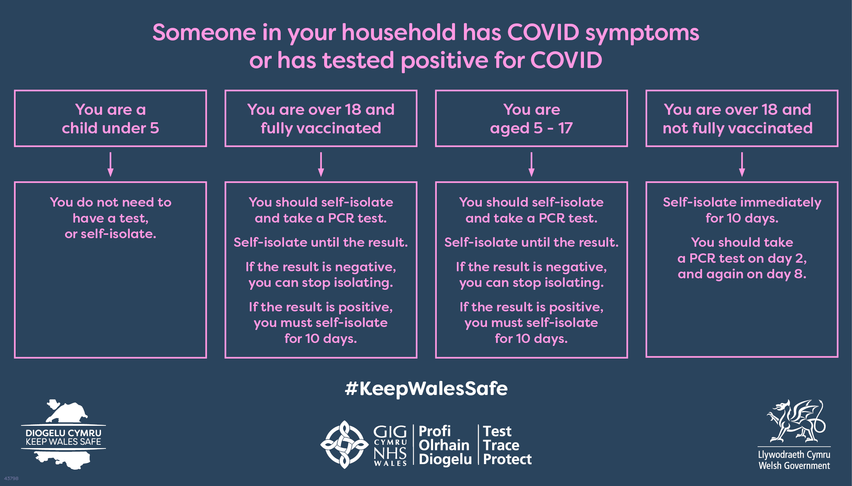

**Remembrance Day – 11th November**

Remembrance Day – Thank you to Pastor Funnell who will be leading our Remembrance Day service. There is currently a range of merchandise on sale in school to support this year’s Poppy Appeal, many thanks for your generosity.

**Christmas Raffle**

We will be holding our annual Christmas raffle this year and would appreciate any kind **donations** from local businesses and members of the community. If you are able to donate or ask companies for donations please can you contact the school office.

Last year the response was tremendous and we were able to use money raised to buy many new inside and outside games for pupils to use in their classes.

**Secondary Admissions 2022 - Important information**

**Closing date for applications is Wednesday 24th November 2021 by 12.00 noon.**

You can apply online by following this link [www.torfaen.gov.uk/secondaryadmissions](http://www.torfaen.gov.uk/secondaryadmissions)

**Aneurin Bevan Health Board – Newsletter on Children’s Health**

Please use the following link to our ‘Spotlight On Newsletter.’ We hope that you find this newsletter useful.

[https://abuhb.nhs.wales/files/clinical-futures/spotlight-on/childrens-healthcare/spotlight-on-round-up-childrens-healthcare-services/](https://eur03.safelinks.protection.outlook.com/?url=https%3A%2F%2Fabuhb.nhs.wales%2Ffiles%2Fclinical-futures%2Fspotlight-on%2Fchildrens-healthcare%2Fspotlight-on-round-up-childrens-healthcare-services%2F&data=04%7C01%7Cgarntegschool.office%40torfaen.gov.uk%7C9ac4189188044cf6b5a908d98e2e9f73%7C2c4d0079c52c4bb3b3cad8eaf1b6b7d5%7C0%7C0%7C637697153157156364%7CUnknown%7CTWFpbGZsb3d8eyJWIjoiMC4wLjAwMDAiLCJQIjoiV2luMzIiLCJBTiI6Ik1haWwiLCJXVCI6Mn0%3D%7C1000&sdata=4NYo%2FEux0OMcs47BNP7IPoB02bv0kv66GPQX%2BtlWYI4%3D&reserved=0)

**Pupil of the week in classes**

|  |  |  |  |
| --- | --- | --- | --- |
| **Foundation Phase** |  | **Key Stage 2** |  |
| **Class** | **Pupil of the Week** | **Class** | **Pupil of the Week** |
| **Nursery – Mrs Attewell** | Morning:  Brooke & Isaac  Afternoon:  Lexi & Bobi-Ray | **Class 7 – Miss Williams** | Harriet |
| **Class 1 - Mrs Ngwenya** | Alexis | **Class 8 - Miss Bones** | Zac |
| **Class 2 – Miss Brooks** | Leia | **Class 9 – Mrs Lewis** | Poppy & Shay |
| **Class 3 – Mr Key** | Callie | **Class 10 – Miss Paske** | Bowayn |
| **Class 4 - Miss Brown** | Mia-Rae | **Class 11 – Mrs Rogers** | Gracie |
| **Class 5 - Mrs Lee** | Jack and Max | **Class 12 – Mrs Messore** | Joe |
| **Class 6 - Miss Carroll** | Athena | **Class 13 - Mrs Parker-Evans** | Daniel |
|  |  | **Class 14 - Mr Phillips** | Rhys |

**Nursery – Ymdrech fawr Meithrin! What a fantastic week we’ve had, you’ve all been superstars with your learning. At the start of the week we looked at different sizes and worked on identifying and ordering our ‘firework’ objects. Then we celebrated Diwali by making and painting diva lamps – they all look beautiful. Give yourselves a marshmallow clap and have a lovely restful weekend. Stay safe this weekend if you are going to watch any fireworks and we look forward to seeing you next week.**

**Dosbarth 1 & 2 – Bendegedig Derbyn! Another fantastic week of learning. This week we have looked at celebrations such as bonfire night and celebrated Diwali by making diva lamps. These will be coming home next week. Bug club usernames and passwords have been sent home, we would really appreciate your children logging in twice a week to read at home with you. Pe days are still a Tuesday and children can wear pe clothes to school on this day. Have a lovely safe weekend if your seeing fireworks.**

**Dosbarth 3 & 4 – Da iawn Blwyddyn Un, What a great first week back! We are continuing our topic ‘The magic in me’ this term and looking forward to learning more exciting and magical things. This week we have been exploring our new story ‘The magic hat’, adding and learning all about bonfire night. PE days are still Wednesday and the children can continue to wear their PE kit to school that day. As the weather gets colder, please make sure the children wear weather appropriate clothing such as jumpers, cardigans and coats. It would also be amazing if the children could bring wellies for them to use in the mud kitchen and forest school areas as we love to use these areas! Have a lovely weekend and stay safe whilst watching the fireworks** 😊🎇

**Dosbarth 5 & 6** - **Da iawn Dosbarth 5 and 6 for an amazing start of our second half term. This week we have continued learning all about our topic Ready Steady Grow! Just a reminder that children can wear their PE kits on Monday (Dosbarth 6) and Thursday (Dosbarth 5). Please send your child to school in warm PE kits as PE will take place outside. Diolch. 😊**

**Dosbarth 7 & 8 –** **Ardderchog for another fantastic week Blwyddyn Tri😊 We have continued our ‘Free to be you and me’ topic, looking at our new story ‘Meerkat Mail’ and celebrating Diwali by designing mehndi patterns. A polite reminder, can all children please have hoodies, jumpers and cardigans labelled and also bring a coat to school for the colder weather. Have a lovely safe weekend everyone watching the fireworks!**

**Dosbarth 9 & 10** –  **Da iawn Dosbarth 9 and 10 for an amazing start of our second half term. This week we have continued learning all about our topic and we are becoming more confident when working independently. Just a reminder that children can wear their PE kits on Tuesdays and Thursday. Please send your child to school in warm PE kits as PE will take place outside. Keep safe over the weekend.**

**Diolch. 😊**

**Dosbarth 11 & 12 – We have had a lovely week back in school. The children have worked really well throughout the week. Just a reminder that spellings are posted on Class dojos weekly, and activities are set on My maths and home reading activities on Bug Club. Have a lovely weekend and enjoy the fireworks. Stay safe.**

**Dosbarth 13 & 14 –**

**It has been lovely to see you all back in school after half term. We have enjoyed working on our design and making tasks this week. We will continue to have PE sessions on Wednesday and Friday. They will continue to be outdoor sessions, so please make sure the sports kit will keep the children warm outside. Enjoy the Bonfire Night celebrations and keep safe over the weekend. See you back in class on Monday.**

Mrs Roche & all the staff at Garnteg Primary School