|  |  |
| --- | --- |
| Description: New Image | GARNTEG PRIMARY SCHOOL  Hillcrest Garndiffaith Pontypool Torfaen NP4 7SJ  01495 742934  Garntegschool.office@torfaen.gov.uk  www.garntegprimary.co.uk |
|  |  |

**Newsletter – 12th November2021**

**This half term our value is: Caring**

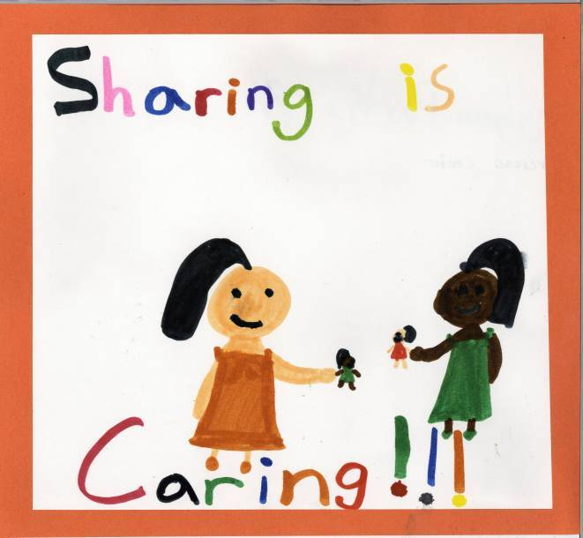

**Cylchlythyr – 12th November 2021**

**Yr hanner tymor hwn ein gwerth yw:Gofalu**

**Important Dates for your diary**

**Children in Need – Friday 19th November**

**Children’s Christmas Lunch - Wednesday 15th December**

**School Finishes for Christmas – Friday 17th December**

**School starts back after Christmas – Tuesday 4th January 2022**

**Additional Jubilee Day – 29th April 2022**

**Inset day - 27th May 2022**

**Inset days - 21st and 22nd July 2022**

**Dear Parents/Carers,**

**Annwyl Rhieni/Sy'n ofalwyr**

**It has been a very thought provoking week with our thoughts centred around Remembrance Day on Thursday. Many thanks to all of you who have bought poppies and other merchandise over the past few weeks to support the British Legion**

**Remembrance Day Assembly**

Thank you Pastor Funnell and Mr Phillips for delivering an excellent Remembrance Day assembly yesterday. Y6 pupils read super prayers and poems which they wrote in class and Mr Key played the last post. 3 pupils form Garnteg will also lay a wreath at the Blaenavon Remembrance Service on Sunday on behalf of the school.



**Children in Need - Friday 19th November**



Children in Need activities will take place within your child’s class this year. We invite the children to wear non-uniform in a variety of colours styles, spots and cosy clothes! There will be fun and exciting events organised by the School Council.

There will be a bucket for children to toss their coins in as they enter the school in the morning and at the end of the day.

**Anuerin Bevan University Health Board Recruitment Event**



**Christmas Raffle**

We will be holding our annual Christmas raffle in the last week of this term and would appreciate any kind **donations** from local businesses and members of the community. If you are able to donate or ask companies for donations please can you contact the school office.

Last year the response was tremendous and we were able to use money raised to buy many new inside and outside games for pupils to use in their classes.

**Christmas Lunch for Pupils**

Christmas Lunch will be held on Wednesday 15th December, if you wish your child to have Christmas Lunch, please let your child’s teacher know via class dojo by Tuesday 30th November. Only Christmas Lunch will be available from the canteen on this day.

**Keeping Children Safe Online**

Each week we will be sharing guides that cover the key things parents/carers should know about the most popular social media and gaming apps used by our learners. These guides can be found in the ‘In The Know’ area of Hwb.

This week is all about **Pokemon Go** – follow the link for age ratings, potential risks and what you can do to keep your child safe [Pokemon Go - Hwb (gov.wales)](https://hwb.gov.wales/zones/keeping-safe-online/in-the-know/pokemon-go/)

**Secondary Admissions 2022 - Important information**

**Closing date for applications is Wednesday 24th November 2021 by 12.00 noon.**

You can apply online by following this link [www.torfaen.gov.uk/secondaryadmissions](http://www.torfaen.gov.uk/secondaryadmissions)

**Pupil of the week in classes**

|  |  |  |  |
| --- | --- | --- | --- |
| **Foundation Phase** |  | **Key Stage 2** |  |
| **Class** | **Pupil of the Week** | **Class** | **Pupil of the Week** |
| **Nursery – Mrs Attewell** | **AM King & Queen –** Tabitha & Louie  **PM King & Queen** **–** Evan & Darcie-Lyn | **Class 7 – Miss Williams** | Kori |
| **Class 1 - Mrs Ngwenya** | Ronan | **Class 8 - Miss Bones** | Summer |
| **Class 2 – Miss Brooks** | Caleb | **Class 9 – Mrs Lewis** | Leo |
| **Class 3 – Mr Key** | Isla | **Class 10 – Miss Paske** | Cai |
| **Class 4 - Miss Brown** | William F | **Class 11 – Mrs Rogers** | Harry |
| **Class 5 - Mrs Lee** | Maximus | **Class 12 – Mrs Messore** | Ffion |
| **Class 6 - Miss Carroll** | Leo and Castiel | **Class 13 - Mrs Parker-Evans** | Jamie |
|  |  | **Class 14 - Mr Phillips** | Ethan E |

**Nursery –** **Bendigedig Meithrin! We have had a wonderful week celebrating Remembrance Day with lots of lovely craft activities. Don't forget to look at our twitter page to see all the amazing things we have been up to! Children are invited to wear comfy clothes to school next Friday for Children in Need. Have a lovely weekend all! Diolch!**

**Dosbarth 1 & 2 – Bendegedig Derbyn for another brilliant week of learning! This week we have been blown away by your artwork that you dedicated to Remembrance Day.**

**We are really enjoying our new book ‘Jack and the Beanstalk’ and I'm sure the children could tell you all about the story at home. Please remember bug club log in’s have been sent home and these will be looked at daily for readers at home. Have a lovely weekend!**

**Dosbarth 3 & 4 – Da iawn Dosbarth 3+4 for another fantastic week! We were so impressed with your understanding of Remembrance Day this week as well as helping our wizard with his adding problems and planning your own ‘magic hat’ poems! We would love to see some more of your lovely home learning so please don’t forget to send home learning logs pictures to us! We have loved visiting forest school this week too, so just a reminder that it would be amazing if the children can bring wellies to keep their feet dry when exploring outdoors in the wet weather. Diolch, have a lovely weekend!**

**Dosbarth 5 & 6** - **What another ffantasteg week we have had in Blwyddyn Dau! You have been working so hard on your Remembrance Day project making your own individual poppies, creating a poppy in nature and writing your own acrostic poems! Please keep an eye on Class Dojo and Twitter for updates and to keep up with all our lovely learning! Please continue to complete home learning logs, my maths activities and bug club for reading at home, all logins have been sent via Class Dojo. Enjoy your weekend 😊**

**Dosbarth 7 & 8 –** **Bendigedig for another fantastic week Blwyddyn Tri😊 You have all enjoyed learning about Remembrance Day and have all showed amazing respect as we remembered all the soldiers. Just a reminder that spellings are posted on Class dojo and home reading activities are on Bug Club.** **A polite reminder can all children please have hoodies, jumpers and cardigans labelled and bring a coat to school for the colder weather. Have a lovely weekend everyone!**

**Dosbarth 9 & 10** –  **Ardderchog Blwyddyn Pedwar for an amazing week of learning. Dosbarth 9 and 10 have been working hard with their Remembrance Day project. Just a reminder to keep up to date with our Class Dojo messages and Twitter, to ensure that you are aware of the events that are coming up in our school diary. A reminder that children are invited to wear comfy clothes to school next Friday for Children in Need. Children can also bring money to take part in some of the Children in Need activities. Have a lovely weekend. Diolch! 😊**

**Dosbarth 11 & 12 – Bendegedig pawb for a fantastic week of learning especially with our Remembrance Day projects. Just a reminder for the children to bring coats into school as the weather changes very quickly. Also children are invited to wear comfy clothes on Friday for Children in Need and bring in donations to take part in fun activities. Have lovely weekend and stay safe.**

**Dosbarth 13 & 14 –** **Diolch yn fawr Dosbarth 13 and 14 for your hard work this week. Well done with your work on Remembrance and thank you to the pupils who helped in our school Remembrance Assembly this week. Next week, we will be taking part in Children in Need Day on Friday. Pupils can wear comfy clothes to school and we will be taking part in lots of Children in Need activities during the day. Enjoy your weekend.**

Mrs Roche & all the staff at Garnteg Primary School